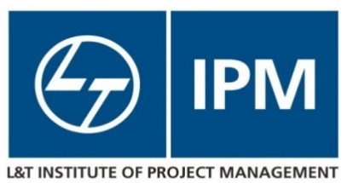

L&T Institute of Project Management, Vadodara
Nomination Form
Program: Construction Project Planning and Management (CPPM)
Date: 9th Dec to 14th Dec 2019
Venue: L&T IPM, KC Residency Campus, Vadodara

Name of the Project:
Name of Funding Agency [Domestic Funding/Externally Aided. If Externally Aided, kindly provide name of Donor]
Name of the Participant :
Designation of the Participant:
Email ID of the Participant :
Contact Number (mandatorily required in case you wish to avail of pick-up/drop facilities):
Government Department and State :
Educational Qualifications of Participant :
Brief description of present responsibilities:
Total Work Experience:
Expectations from this Program:
Office Postal Address:
Participant Journey Details: | Arrival Date :  Arrival From :  Flight No /:  Train Number  ETA : | Departure Date :  Departure To :  Flight No /:  Train Number  ETD :
Requirement for complimentary pick up and drop (please tick in the box) | Yes | No
Payment Details : | Payment Via DD :  DD number:  DD Date:  DD issue Bank Details:  The Demand Draft needs to be in favour of - Larsen & Toubro Limited, payable at Mumbai.  (Please mention your name, contact number and program name, i.e., ‘Construction Project Planning and Management’ on the back of the DD)
Payment Via Bank Wire Transfer :
Mode of transfer: NEFT, RTGS or IMPS
Bank Details:
Account Details:

Program Coordinator (Administration)  Mr. Amit Tiwari  E-mail: amit.tiwari@Lntipm.org  Telephone: +91 265 2453111  Mobile: +91 8000215038 | Address:  L&T Institute of Project Management  IPM / PTI Building - KC Residency Campus, Gate No. 4,  Behind L&T Knowledge city, Off National Highway # 8, Between Waghodia-Ajwa Road bypass crossing  Near Village : Ankhol  Vadodara – 390019, Gujarat

